|  |
| --- |
| Circle Language Spec: Commands |

## Inactive Command Class Redirection in a Diagram

The concept of inactive command class redirection is explained in the article *Inactive Command Class Redirection*. The current article explains its expression in a diagram.

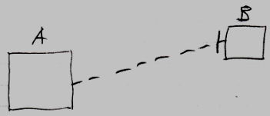

Inactive command symbol A is a square because it is an *inactive* command. Inactive command symbol A redirects its class to the inactive command symbol B. Symbol B is also a square because it is also an *inactive* command. The redirection from command A to command B is displayed as a dashed line, which is a class line. The direction of the line is indicated by a line dissector, close to symbol B.

Symbol B could also be replaced by a diamond, making an *executable* command the prototype for a new command object. That is less common, but possible all the same.

